Complete Polygon–Circle Tangency
# Source: AI Source: Provided by: [Data Path: Persons Table -> ID Column: 1, Name_En Column: Motasem Essam] -> From: [ChatGPT] on [7/25/2026]
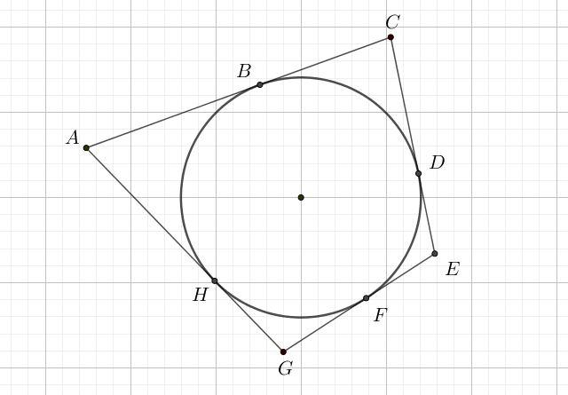
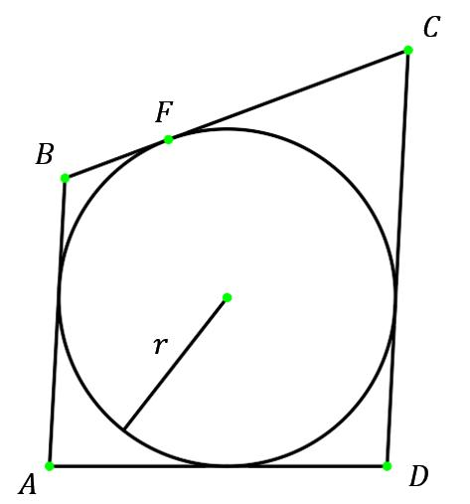
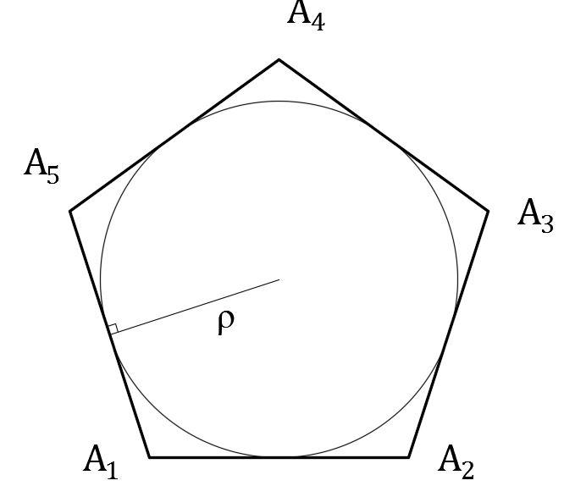
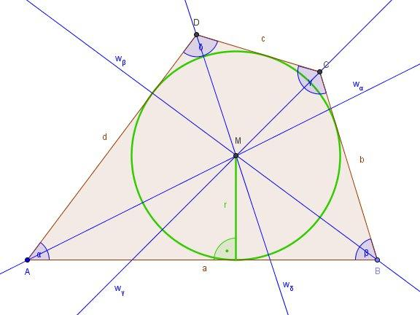
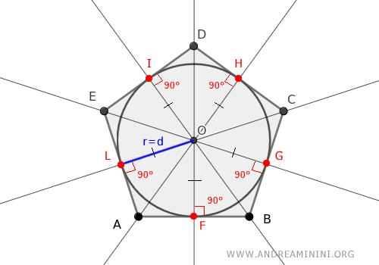

Definition
# Source: AI Source: Provided by: [Data Path: Persons Table -> ID Column: 1, Name_En Column: Motasem Essam] -> From: [ChatGPT] on [7/25/2026]
Complete Polygon–Circle Tangency is a type of Polygon–Circle Tangency in which a circle is tangent to every side of a polygon.
Each side of the polygon touches the circle at exactly one point of tangency.
The circle is therefore an inscribed circle of the polygon, and the polygon is called a tangential polygon.
If the polygon has $n$sides, complete tangency means:
$$\boxed{\text{Number of tangent sides}=n}$$
and, under ordinary non-degenerate conditions, there are $n$corresponding tangency points.

Fundamental Concept
# Source: AI Source: Provided by: [Data Path: Persons Table -> ID Column: 1, Name_En Column: Motasem Essam] -> From: [ChatGPT] on [7/25/2026]
Let a polygon have sides:
$$l_{1},l_{2},…,l_{n}$$
and let a circle with center $O$and radius $r$be tangent to every side.
For every side $l_{i}$, there is a tangency point $T_{i}$such that:
$$\boxed{OT_{i}⊥l_{i}}$$
Because every $OT_{i}$is a radius:
$$\boxed{OT_{1}=OT_{2}=⋯=OT_{n}=r}$$
Therefore, the center of the circle is at the same perpendicular distance from every side of the polygon.

Main Parts
# Source: AI Source: Provided by: [Data Path: Persons Table -> ID Column: 1, Name_En Column: Motasem Essam] -> From: [ChatGPT] on [7/25/2026]
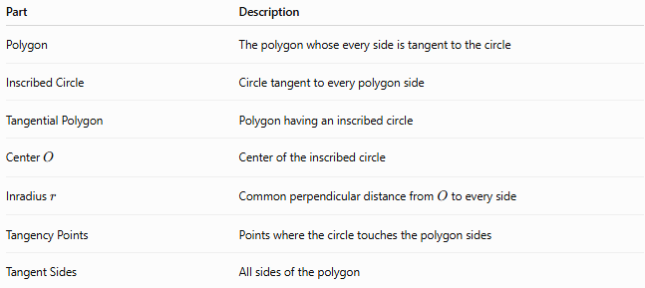
Part | Description
Polygon | The polygon whose every side is tangent to the circle
Inscribed Circle | Circle tangent to every polygon side
Tangential Polygon | Polygon having an inscribed circle
Center $O$ | Center of the inscribed circle
Inradius $r$ | Common perpendicular distance from $O$to every side
Tangency Points | Points where the circle touches the polygon sides
Tangent Sides | All sides of the polygon

Defining Properties

1-Every Side Is Tangent
# Source: AI Source: Provided by: [Data Path: Persons Table -> ID Column: 1, Name_En Column: Motasem Essam] -> From: [ChatGPT] on [7/25/2026]
For an $n$-sided polygon:
$$\boxed{l_{1},l_{2},…,l_{n}\text{ are all tangent to the circle}}$$
Thus:
$$\boxed{k=n}$$
where $k$is the number of tangent sides.

2-One Tangency Point on Each Side
# Source: AI Source: Provided by: [Data Path: Persons Table -> ID Column: 1, Name_En Column: Motasem Essam] -> From: [ChatGPT] on [7/25/2026]
For each side $l_{i}$:
$$\boxed{T_{i}∈l_{i}}$$
and:
$$\boxed{OT_{i}⊥l_{i}}$$

3-Equal Perpendicular Distances
# Source: AI Source: Provided by: [Data Path: Persons Table -> ID Column: 1, Name_En Column: Motasem Essam] -> From: [ChatGPT] on [7/25/2026]
The center has equal distances from all sides:
$$\boxed{d\left(O , l_{1}\right)=d\left(O , l_{2}\right)=⋯=d\left(O , l_{n}\right)=r}$$

4-The Circle Lies Inside the Polygon
# Source: AI Source: Provided by: [Data Path: Persons Table -> ID Column: 1, Name_En Column: Motasem Essam] -> From: [ChatGPT] on [7/25/2026]
For a conventional convex tangential polygon, the circle lies completely inside the polygon and touches each side internally.

Basic Diagram
# Source: AI Source: Provided by: [Data Path: Persons Table -> ID Column: 1, Name_En Column: Motasem Essam] -> From: [ChatGPT] on [7/25/2026]
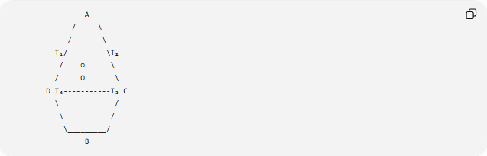
A
/ \
/ \
T₁/ \T₂
/ ○ \
/ O \
D T₄-----------T₃ C
\ /
\ /
\_________/
B
The exact shape depends on the polygon, but every side touches the circle.
For every tangency point:
$$\boxed{OT_{i}⊥\text{corresponding side}}$$

Inscribed Circle
# Source: AI Source: Provided by: [Data Path: Persons Table -> ID Column: 1, Name_En Column: Motasem Essam] -> From: [ChatGPT] on [7/25/2026]
A circle tangent to every side of a polygon is called an inscribed circle of that polygon.
The polygon is called a tangential polygon.
Therefore:
$$\boxed{\text{Complete Polygon–Circle Tangency }⟺\text{ Inscribed Circle}}$$
for the standard convex-polygon setting.

Radius and Tangency Points
# Source: AI Source: Provided by: [Data Path: Persons Table -> ID Column: 1, Name_En Column: Motasem Essam] -> From: [ChatGPT] on [7/25/2026]
Let the circle have radius $r$.
For every tangency point $T_{i}$:
$$\boxed{OT_{i}=r}$$
and:
$$\boxed{OT_{i}⊥l_{i}}$$
Therefore:
$$\boxed{OT_{1}=OT_{2}=⋯=OT_{n}=r}$$
This is why the circle can simultaneously be tangent to all sides.

Tangency Points and Polygon Vertices
# Source: AI Source: Provided by: [Data Path: Persons Table -> ID Column: 1, Name_En Column: Motasem Essam] -> From: [ChatGPT] on [7/25/2026]
Suppose two adjacent sides meet at vertex $A$.
If they touch the circle at $T_{1}$and $T_{2}$, then the two tangent segments from $A$are equal:
$$\boxed{AT_{1}=AT_{2}}$$
Similarly, if the polygon has vertices $A,B,C,…$, corresponding tangent segments from each vertex are equal.
For a quadrilateral:
$$AT_{1}=AT_{2} \\ BT_{2}=BT_{3} \\ CT_{3}=CT_{4} \\ DT_{4}=DT_{1}$$
These relationships are fundamental in tangential polygons.

Area of a Tangential Polygon
# Source: AI Source: Provided by: [Data Path: Persons Table -> ID Column: 1, Name_En Column: Motasem Essam] -> From: [ChatGPT] on [7/25/2026]
A particularly important property is:
$$\boxed{A=\frac{1}{2}Pr}$$
where:
- $A$= area of the polygon
- $P$= perimeter
- $r$= inradius
Why?
The polygon can be divided into triangles by connecting the center $O$to every vertex.
Each triangle has height $r$, because the circle is tangent to every side.
Thus:
$$A=\frac{1}{2}ar+\frac{1}{2}br+\frac{1}{2}cr+⋯$$
Factoring:
$$A=\frac{1}{2}\left(a+b+c+⋯ \right)r$$
Therefore:
$$\boxed{A=\frac{1}{2}Pr}$$

Perimeter–Area Relationship
# Source: AI Source: Provided by: [Data Path: Persons Table -> ID Column: 1, Name_En Column: Motasem Essam] -> From: [ChatGPT] on [7/25/2026]
From:
$$A=\frac{1}{2}Pr$$
we can obtain:
$$\boxed{r=\frac{2A}{P}}$$
and:
$$\boxed{P=\frac{2A}{r}}$$
These formulas apply to a tangential polygon.

Regular Polygon as a Special Case
# Source: AI Source: Provided by: [Data Path: Persons Table -> ID Column: 1, Name_En Column: Motasem Essam] -> From: [ChatGPT] on [7/25/2026]
Every regular polygon has complete polygon–circle tangency.
Its inscribed circle is tangent to every side.
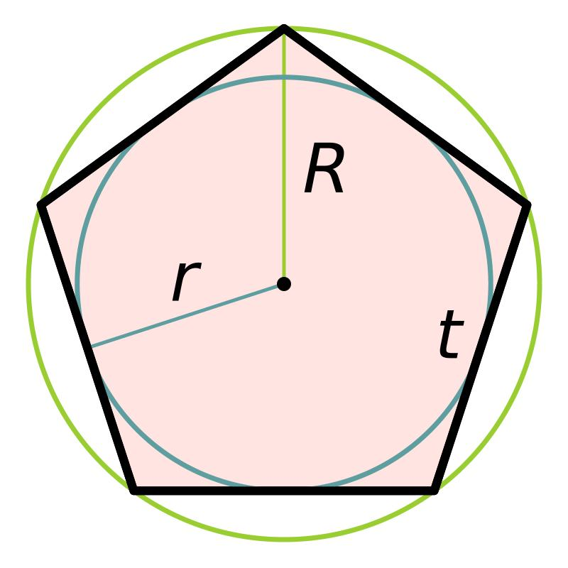
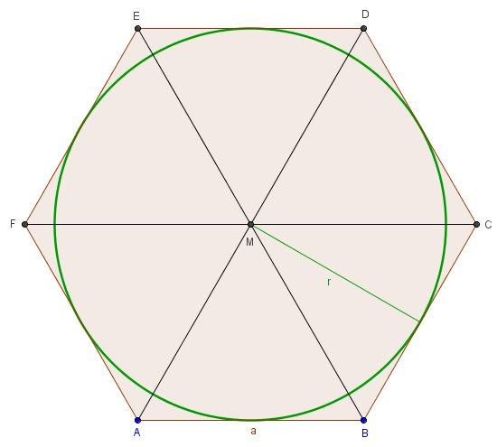
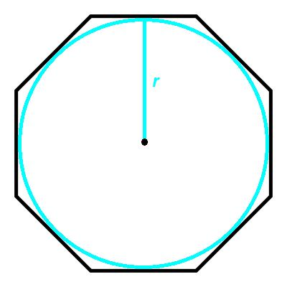
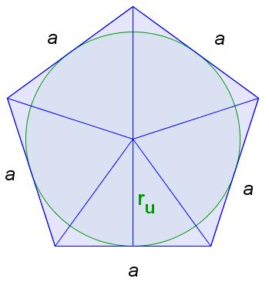
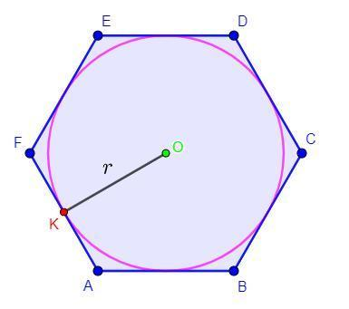
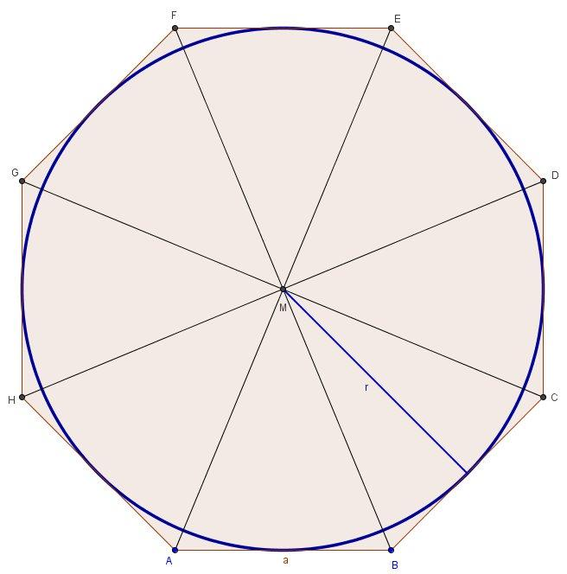
For a regular $n$-gon with side length $a$, the inradius is:
$$\boxed{r=\frac{a}{2tan⁡\left({180}^{∘}/n\right)}}$$
The inradius is also called the apothem:
$$\boxed{r=\text{apothem}}$$
Its area is:
$$\boxed{A=\frac{1}{2}Pr}$$

Triangle
# Source: AI Source: Provided by: [Data Path: Persons Table -> ID Column: 1, Name_En Column: Motasem Essam] -> From: [ChatGPT] on [7/25/2026]
Every non-degenerate triangle has an incircle.
Therefore, every triangle can have complete polygon–circle tangency.
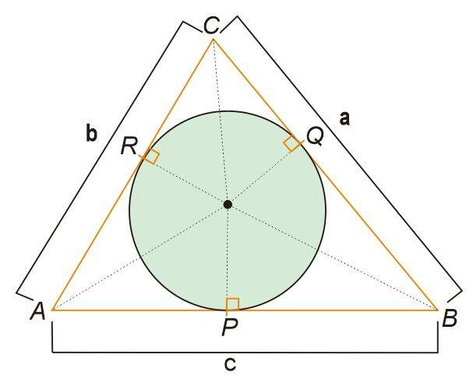
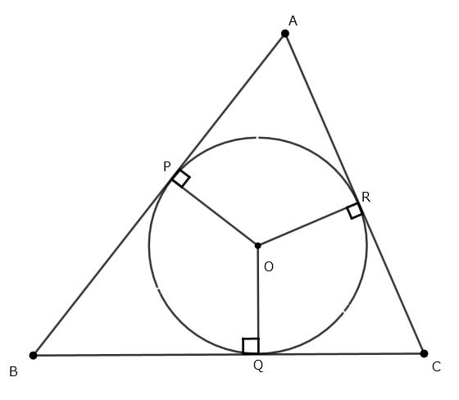
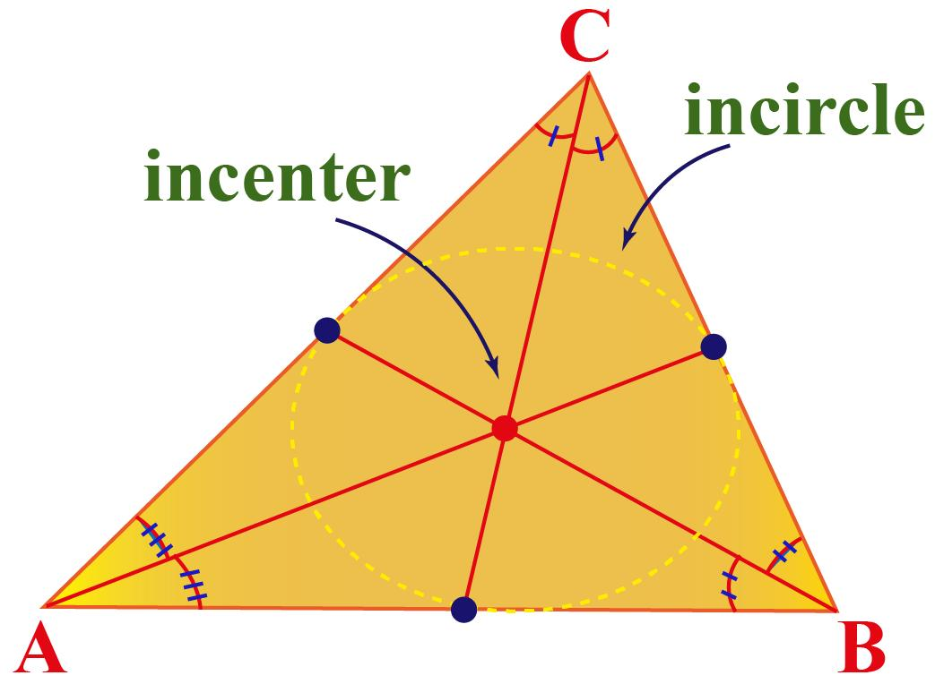
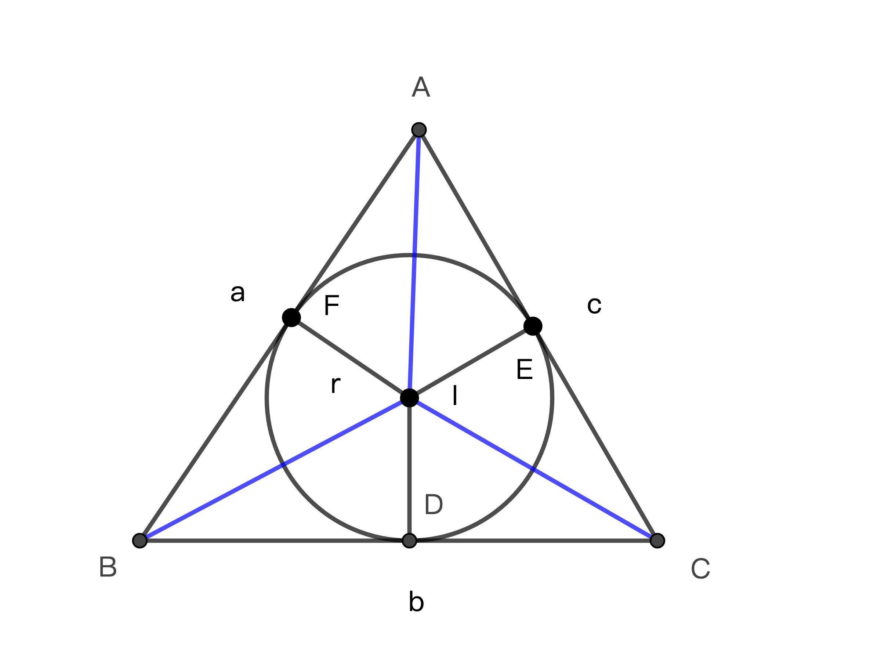
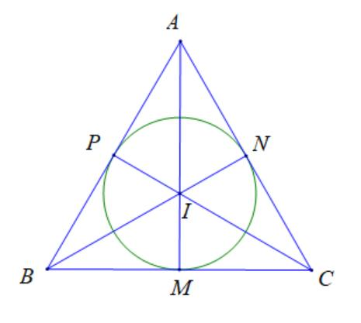
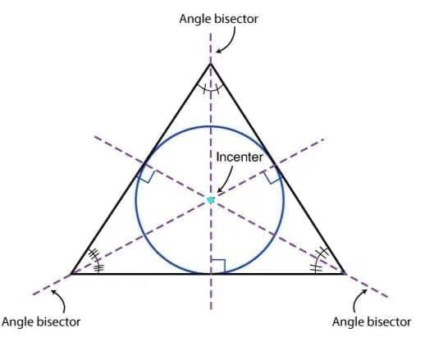
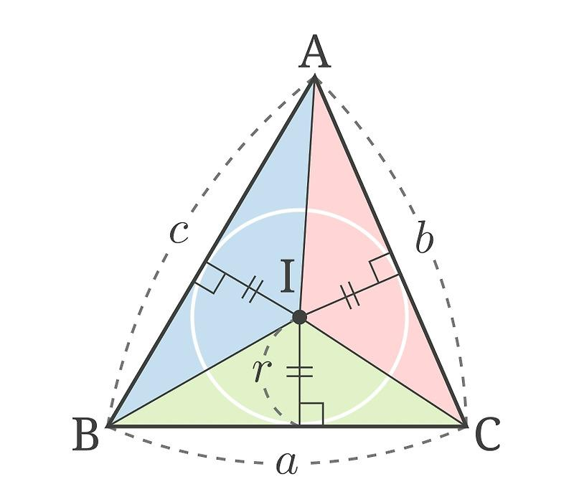
The center of the incircle is the incenter, which is the intersection of the three internal angle bisectors.
The inradius is:
$$\boxed{r=\frac{A}{s}}$$
where:
$$\boxed{s=\frac{a+b+c}{2}}$$
is the semiperimeter.
Therefore:
$$\boxed{r=\frac{2A}{a+b+c}}$$

Quadrilateral
# Source: AI Source: Provided by: [Data Path: Persons Table -> ID Column: 1, Name_En Column: Motasem Essam] -> From: [ChatGPT] on [7/25/2026]
Not every quadrilateral has an inscribed circle.
A convex quadrilateral that has a circle tangent to all four sides is called a tangential quadrilateral.
For such a quadrilateral:
$$\boxed{AB+CD=BC+DA}$$
This is the classical Pitot relation.
For a convex quadrilateral, this equality is also sufficient for the existence of an incircle under the usual geometric conditions.

General Polygon
# Source: AI Source: Provided by: [Data Path: Persons Table -> ID Column: 1, Name_En Column: Motasem Essam] -> From: [ChatGPT] on [7/25/2026]
For an $n$-sided tangential polygon:
$$\boxed{k=n}$$
where $k$is the number of tangent sides.
The circle is tangent to every side:
$$\boxed{d\left(O , l_{1}\right)=d\left(O , l_{2}\right)=⋯=d\left(O , l_{n}\right)=r}$$
and:
$$\boxed{A=\frac{1}{2}Pr}$$

Complete vs Multiple-Side Tangency
# Source: AI Source: Provided by: [Data Path: Persons Table -> ID Column: 1, Name_En Column: Motasem Essam] -> From: [ChatGPT] on [7/25/2026]
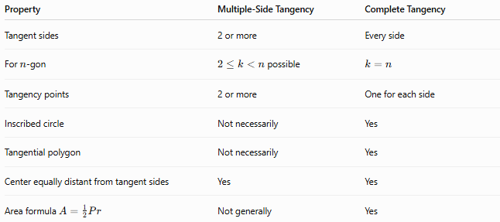
Property | Multiple-Side Tangency | Complete Tangency
Tangent sides | 2 or more | Every side
For $n$-gon | $2≤k<n$possible | $$k=n$$
Tangency points | 2 or more | One for each side
Inscribed circle | Not necessarily | Yes
Tangential polygon | Not necessarily | Yes
Center equally distant from tangent sides | Yes | Yes
Area formula $A=\frac{1}{2}Pr$ | Not generally | Yes
The key distinction is:
$$\boxed{\text{Complete Tangency}=\text{All-Side Tangency}}$$

Complete Tangency vs Circumscribed Polygon
# Source: AI Source: Provided by: [Data Path: Persons Table -> ID Column: 1, Name_En Column: Motasem Essam] -> From: [ChatGPT] on [7/25/2026]
A polygon with a circle tangent to every side can also be described as a polygon circumscribed about a circle.
The terminology depends on the viewpoint:
- From the circle's viewpoint → the circle is inscribed in the polygon.
- From the polygon's viewpoint → the polygon is circumscribed about the circle.
Thus:
$$\boxed{\text{Inscribed Circle}≡\text{Circle Tangent to Every Polygon Side}}$$
and:
$$\boxed{\text{Tangential Polygon}≡\text{Polygon Circumscribed About a Circle}}$$

Important Special Case: Center at Equal Distance from All Sides
# Source: AI Source: Provided by: [Data Path: Persons Table -> ID Column: 1, Name_En Column: Motasem Essam] -> From: [ChatGPT] on [7/25/2026]
A circle can be tangent to every side only if its center has the same perpendicular distance from all the sides:
$$\boxed{d\left(O , l_{1}\right)=d\left(O , l_{2}\right)=⋯=d\left(O , l_{n}\right)}$$
This common distance is the inradius:
$$\boxed{r}$$
Thus, the center $O$is a point equidistant from all polygon sides.

Example
# Source: AI Source: Provided by: [Data Path: Persons Table -> ID Column: 1, Name_En Column: Motasem Essam] -> From: [ChatGPT] on [7/25/2026]
Suppose a tangential polygon has:
$$P=40\text{ cm}$$
and inradius:
$$r=5\text{ cm}$$
Its area is:
$$A=\frac{1}{2}Pr \\ A=\frac{1}{2}\left(40\right)\left(5\right) \\ \boxed{A=100{\text{ cm}}^{2}}$$
Because the circle is tangent to every side, the polygon has complete polygon–circle tangency.

Applications
# Source: AI Source: Provided by: [Data Path: Persons Table -> ID Column: 1, Name_En Column: Motasem Essam] -> From: [ChatGPT] on [7/25/2026]
Complete polygon–circle tangency is important in:
- Triangle geometry
- Regular polygon geometry
- Tangential polygon constructions
- Architecture
- Mechanical design
- CAD
- Engineering
- Computational geometry
- Optimization
- Circular and polygonal packing
- Technical drawing

Key Points
# Source: AI Source: Provided by: [Data Path: Persons Table -> ID Column: 1, Name_En Column: Motasem Essam] -> From: [ChatGPT] on [7/25/2026]
- Complete Polygon–Circle Tangency means that a circle is tangent to every side of a polygon.
- It is also called all-side tangency.
- The circle is an inscribed circle.
- The polygon is a tangential polygon.
- Every side has a corresponding tangency point.
- Every radius to a tangency point is perpendicular to its side:
$$\boxed{OT_{i}⊥l_{i}}$$
- The center is equally distant from every side:
$$\boxed{d\left(O , l_{i}\right)=r}$$
- For a tangential polygon:
$$\boxed{A=\frac{1}{2}Pr}$$
- Every triangle has an incircle.
- Not every polygon has an inscribed circle.
- Every regular polygon has an inscribed circle.
- Complete tangency is the all-side special case of multiple-side tangency.

Conclusion
# Source: AI Source: Provided by: [Data Path: Persons Table -> ID Column: 1, Name_En Column: Motasem Essam] -> From: [ChatGPT] on [7/25/2026]
Complete Polygon–Circle Tangency occurs when a circle touches every side of a polygon. It is the most complete form of polygon–circle tangency and is equivalent, in the standard convex setting, to the polygon having an inscribed circle.
The defining relationships are:
$$\boxed{\text{Every polygon side is tangent to the circle}} \\ \boxed{OT_{i}⊥l_{i}} \\ \boxed{d\left(O , l_{1}\right)=d\left(O , l_{2}\right)=⋯=d\left(O , l_{n}\right)=r}$$
and the important area relationship is:
$$\boxed{A=\frac{1}{2}Pr}$$
So the hierarchy is:
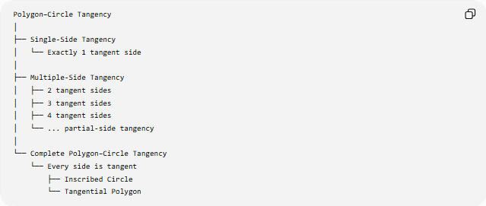
Polygon–Circle Tangency
│
├── Single-Side Tangency
│ └── Exactly 1 tangent side
│
├── Multiple-Side Tangency
│ ├── 2 tangent sides
│ ├── 3 tangent sides
│ ├── 4 tangent sides
│ └── ... partial-side tangency
│
└── Complete Polygon–Circle Tangency
└── Every side is tangent
├── Inscribed Circle
└── Tangential Polygon

